Cover Page
Business Name: VicNicks
Team Members:
- Nicholas M. Ricci (Username – nricci0462)
- Victor K. Dimitrov (Username – vdimitrov4252)
Username: Tech Squad
DB Name: nricci0462_VicNicks_db_store

Executive Summary
Business: VicNicks is dedicated to catering to the dynamic needs of the tech community by offering cutting-edge solutions and services. With a focus on innovation and customer satisfaction, VicNicks has established itself as a prominent player in the industry, leveraging expertise and forward-thinking strategies to stay ahead in the rapidly evolving tech landscape.
Problem: VicNicks' rapid growth over the past three years has led to a significant increase in data volume and complexity. Relying on spreadsheet-based data management has become increasingly inadequate and cumbersome, hindering operational efficiency and the company's ability to adapt to evolving market demands.
Solution: VicNicks will modernize its data infrastructure by adopting a comprehensive database solution tailored for rapid growth. This transition from spreadsheets to a sophisticated database architecture will enhance data accessibility, streamline operations, and empower informed decision-making, enabling VicNicks to unlock new opportunities for innovation and growth in the tech industry.

Problems, Constraints, & Objectives
Problems:
VicNicks faces critical challenges: outdated systems cause inefficiencies, data volume strains infrastructure, and maintaining integrity amid expansion poses concerns.
Constraints:
Limited finances, time constraints, and organizational resistance hinder technological upgrades, necessitating effective change management.
Objectives:
VicNicks has meticulously crafted a comprehensive set of objectives aimed at overcoming existing challenges and propelling the company towards sustainable growth. Central to these objectives is the modernization of its data infrastructure, transitioning to scalable databases to enhance data accessibility, integrity, and security. Concurrently, VicNicks seeks to optimize efficiency through the strategic implementation of automation technologies, reducing manual workload and accelerating workflows. Additionally, the company is committed to fostering a culture of innovation by empowering employees with actionable insights derived from data analytics, encouraging experimentation, collaboration, and the generation of innovative solutions. Moreover, ensuring compliance and security remains a top priority for VicNicks, with the implementation of robust measures to mitigate risks and safeguard sensitive information. Finally, VicNicks aims to enhance the customer experience by leveraging data analytics to deliver personalized service and proactive engagement, thereby fostering long-term loyalty and advocacy.
Scope & Boundaries (with Business Rules).
Scope:
VicNicks defines its database management system (DBMS) to cover core business processes: CRM, sales, inventory, finance, and HR. Clear boundaries ensure alignment with strategic objectives.
Boundaries:
The DBMS handles essential data, excluding non-essential information, with structured management practices maintaining data integrity and security.
Business Rules:
One-to-One (1:1) Relationship: Employees are assigned to departments, each overseen by a single manager. This relationship is represented by the links between EMPLOYEE, DEPARTMENT, and MANAGER tables. The department ID in EMPLOYEE corresponds to DEPARTMENT, and DEPARTMENT's manager ID connects to MANAGER. Additionally, each customer is uniquely identified by their email address in the CUSTOMER table. Similarly, channels, invoice history, and inventory records have unique identifiers such as CHANNEL_ID, HISTORY_ID, and INVENTORY_ID, respectively.
One-to-Many (1:M) Relationship: Departments can have multiple employees, as illustrated by the DEPARTMENT to EMPLOYEE connection. Each department ID in DEPARTMENT relates to multiple employee records in EMPLOYEE. Similarly, channels can have multiple invoice history records, and inventory items can have multiple instances recorded in the inventory table. Each product is categorized into one category, demonstrated by the PRODUCT_CATEGORY column in the PRODUCT table.
Many-to-Many (M:N) Relationship: Customers can purchase multiple products, reflected in the relationship between CUSTOMER and INVOICE tables. Each invoice can include multiple products bought by a customer, capturing the dynamic interactions between customers and products. Similarly, channels can have multiple inventory items associated with them, and each inventory item can be associated with multiple channels through sales or distribution channels.
ERD of VicNicks_db_store
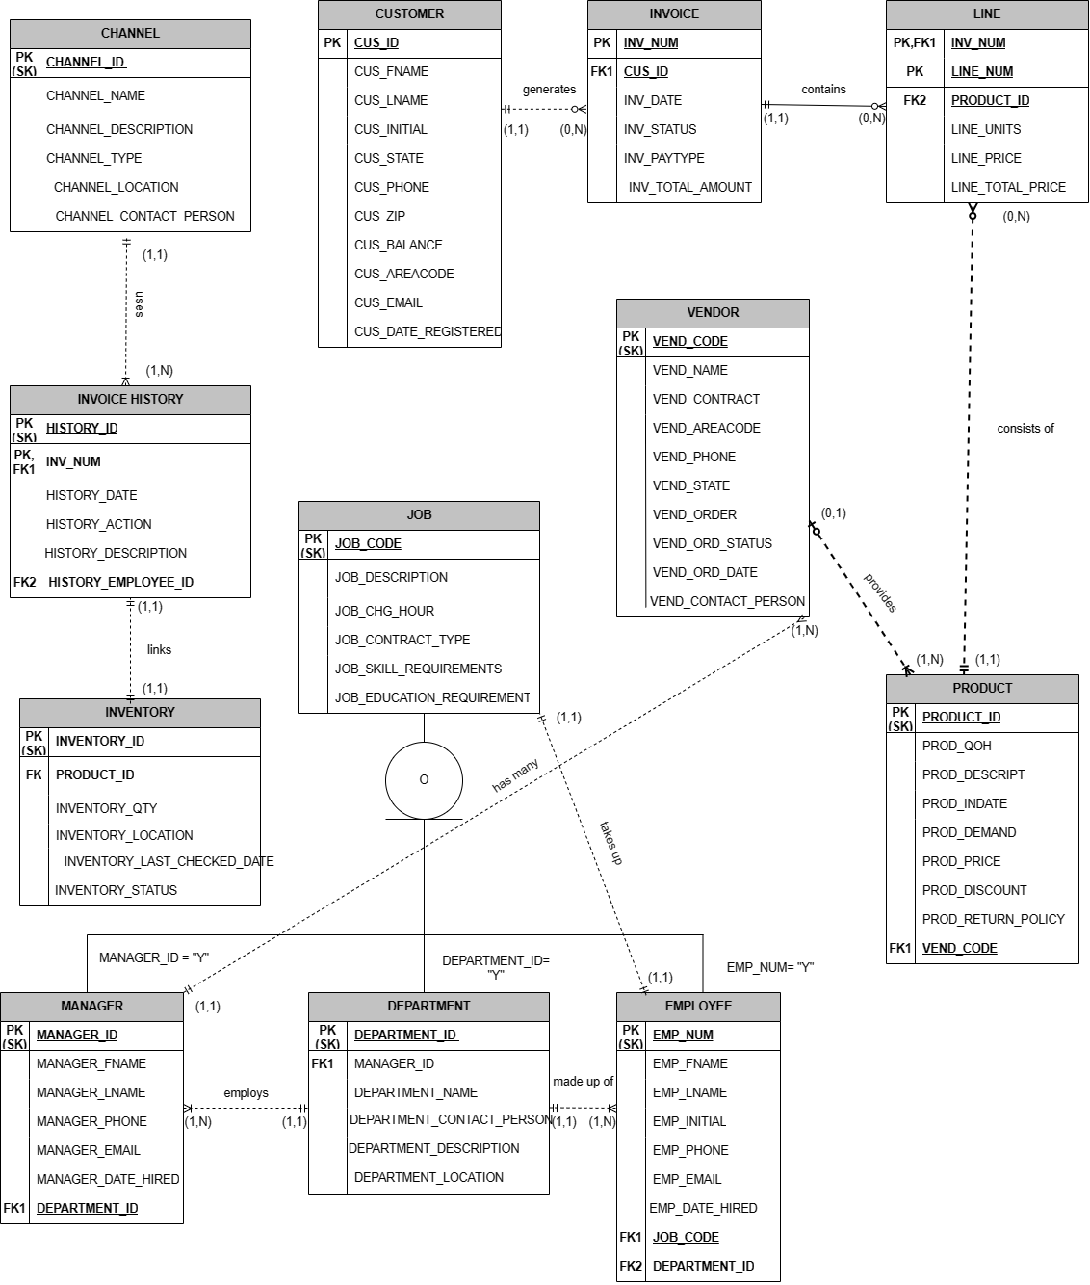

SQL Dump/Backup
EmberDB> mysqldump –u nricci0462 –p –h 10.200.208.126 --where=”1 limit 20” nricci0462_VicNicks_db_store > ~/nricci0462_db_backup_first_page.sql
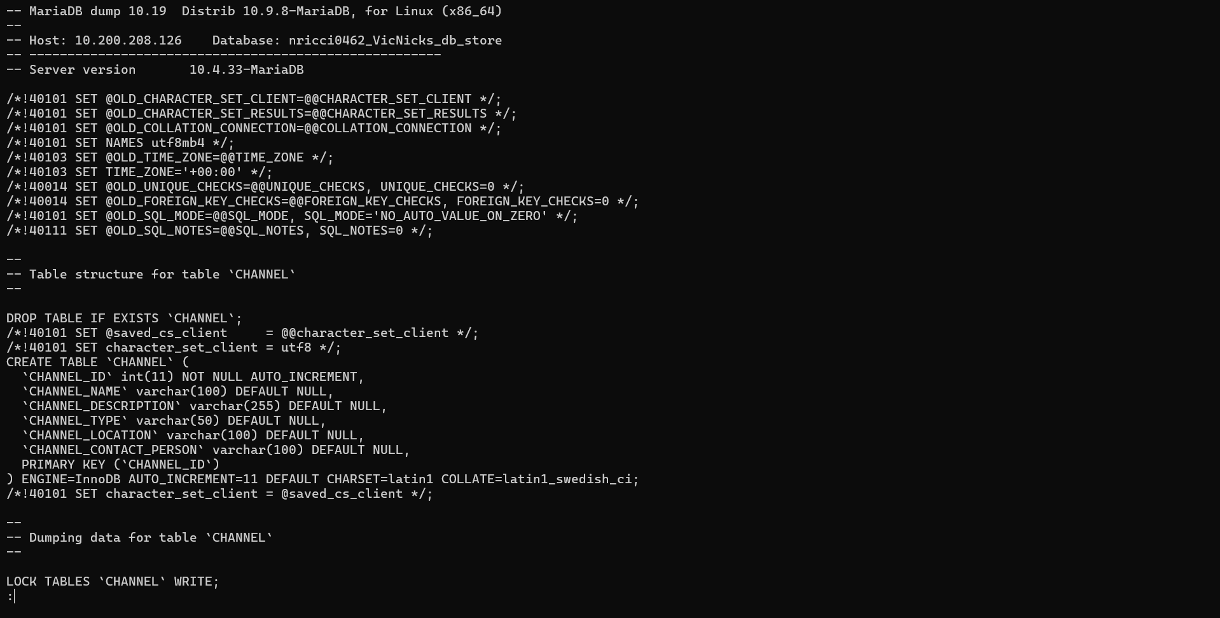

Output of SQL Query to show a specific invoice based on a customer name and date of purchase

MariaDB> SELECT I.INV_NUM, I.INV_DATE, I.INV_STATUS, I.INV_PAYTYPE, C.CUS_FNAME, C.CUS_LNAME FROM INVOICE AS I JOIN CUSTOMER AS C ON I.CUS_ID = C.CUS_ID WHERE C.CUS_FNAME = ‘John’ AND C.CUS_LNAME = ‘Doe’ AND I.INV_DATE = ‘2024-03-01';
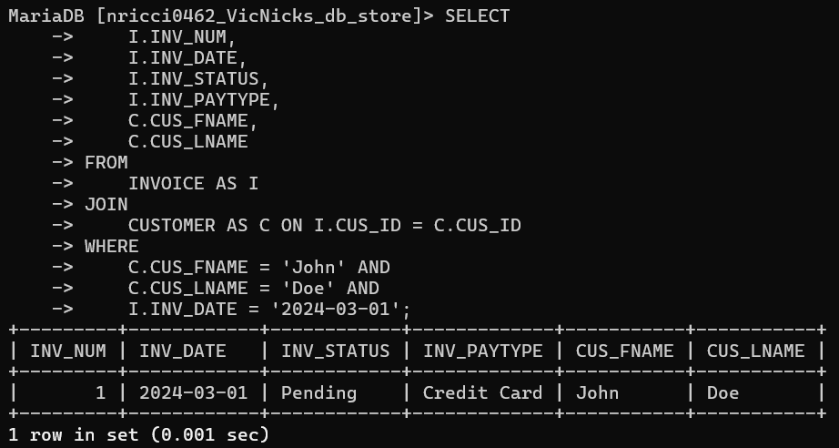

Output of SQL Query to show a current inventory of all products sold within a date range

MariaDB> SELECT P.PRODUCT_ID, P.PRODUCT_DESCRIPTION AS Product_Description, SUM(L.LINE_UNITS) AS Total_Units_Sold FROM LINE L JOIN PRODUCT P ON L.PRODUCT_ID = P.PRODUCT_ID JOIN INVOICE I ON L.INV_NUM = I.INV_NUM WHERE I.INV_DATE BETWEEN ‘2024-03-01' AND ‘2024-03-31' GROUP BY P.PRODUCT_ID, P.PRODUCT_DESCRIPTION;
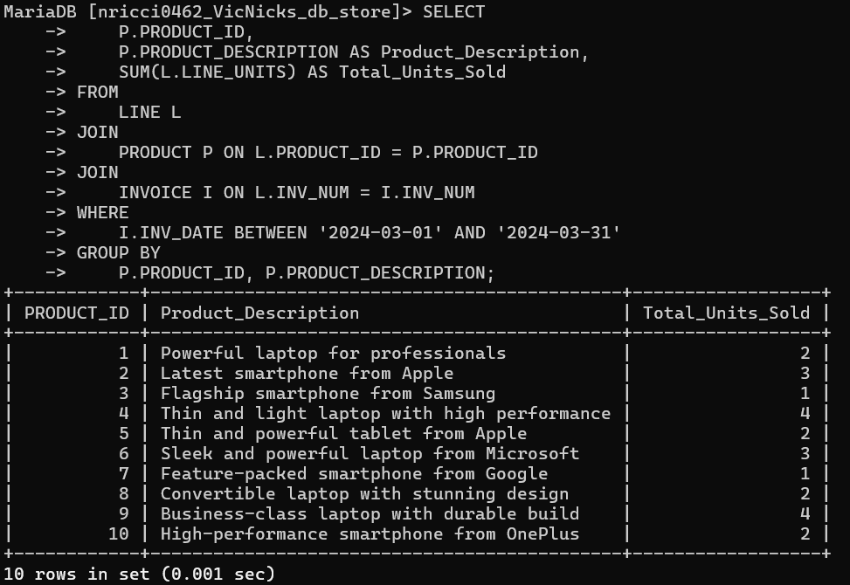

Output of SQL Query to show a current inventory of all products that match one specific product type
MariaDB> SELECT P.PRODUCT_ID, P.PRODUCT_DESCRIPTION AS Product_Description, SUM(L.LINE_UNITS) AS Total_Units_Sold FROM LINE L JOIN PRODUCT P ON L.PRODUCT_ID = P.PRODUCT_ID JOIN INVOICE I ON L.INV_NUM = I.INV_NUM WHERE P.PRODUCT_CATEGORY = ‘Laptops’ AND I.INV_DATE BETWEEN ‘2024-03-01' AND ‘2024-03-31' GROUP BY P.PRODUCT_ID, P.PRODUCT_DESCRIPTION;
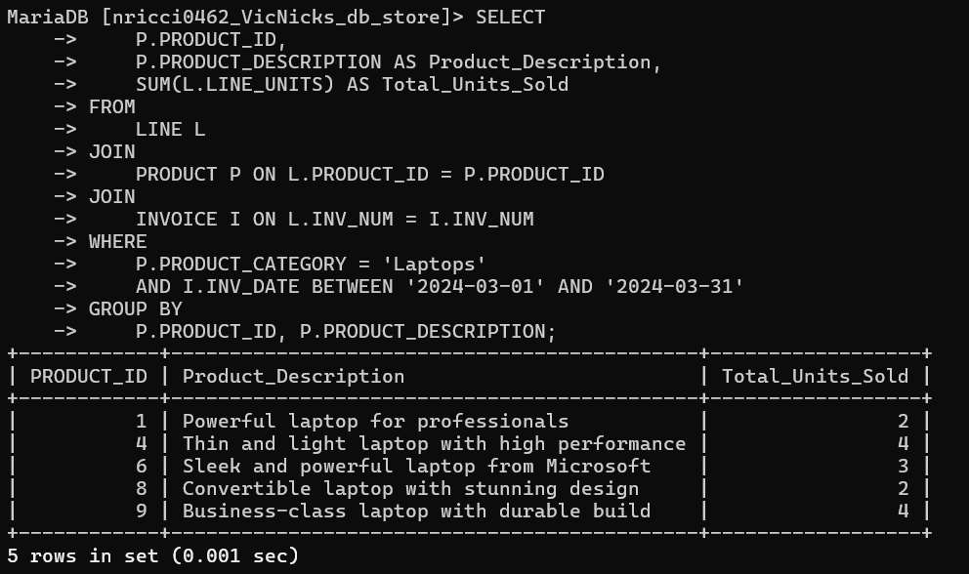

Output of SQL stored procedure that allows a user to pass in a value and in order to join two tables to produce an output
MariaDB> DELIMITER //
CREATE PROCEDURE GetProductDetails (IN product_type VARCHAR(50))
BEGIN
SELECT PRODUCT_ID, PRODUCT_NAME, PRODUCT_DESCRIPTION, PRODUCT_PRICE, PRODUCT_CATEGORY FROM PRODUCT WHERE PRODUCT_CATEGORY = product_type;
END //
MariaDB> DELIMITER;
MariaDB> CALL GetProductDetails(‘Laptops’);
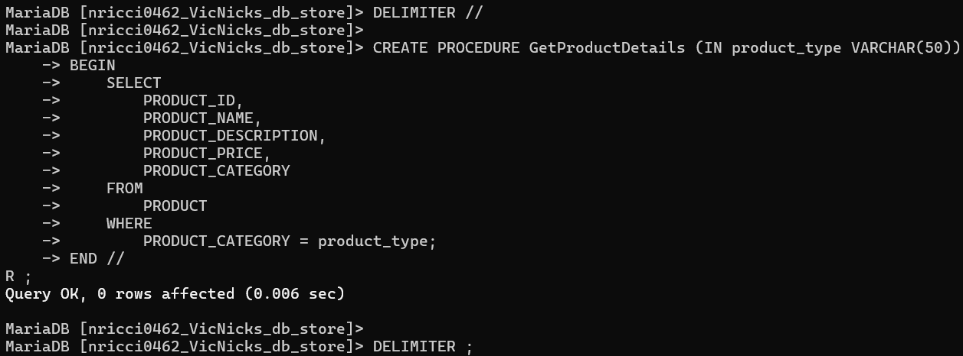
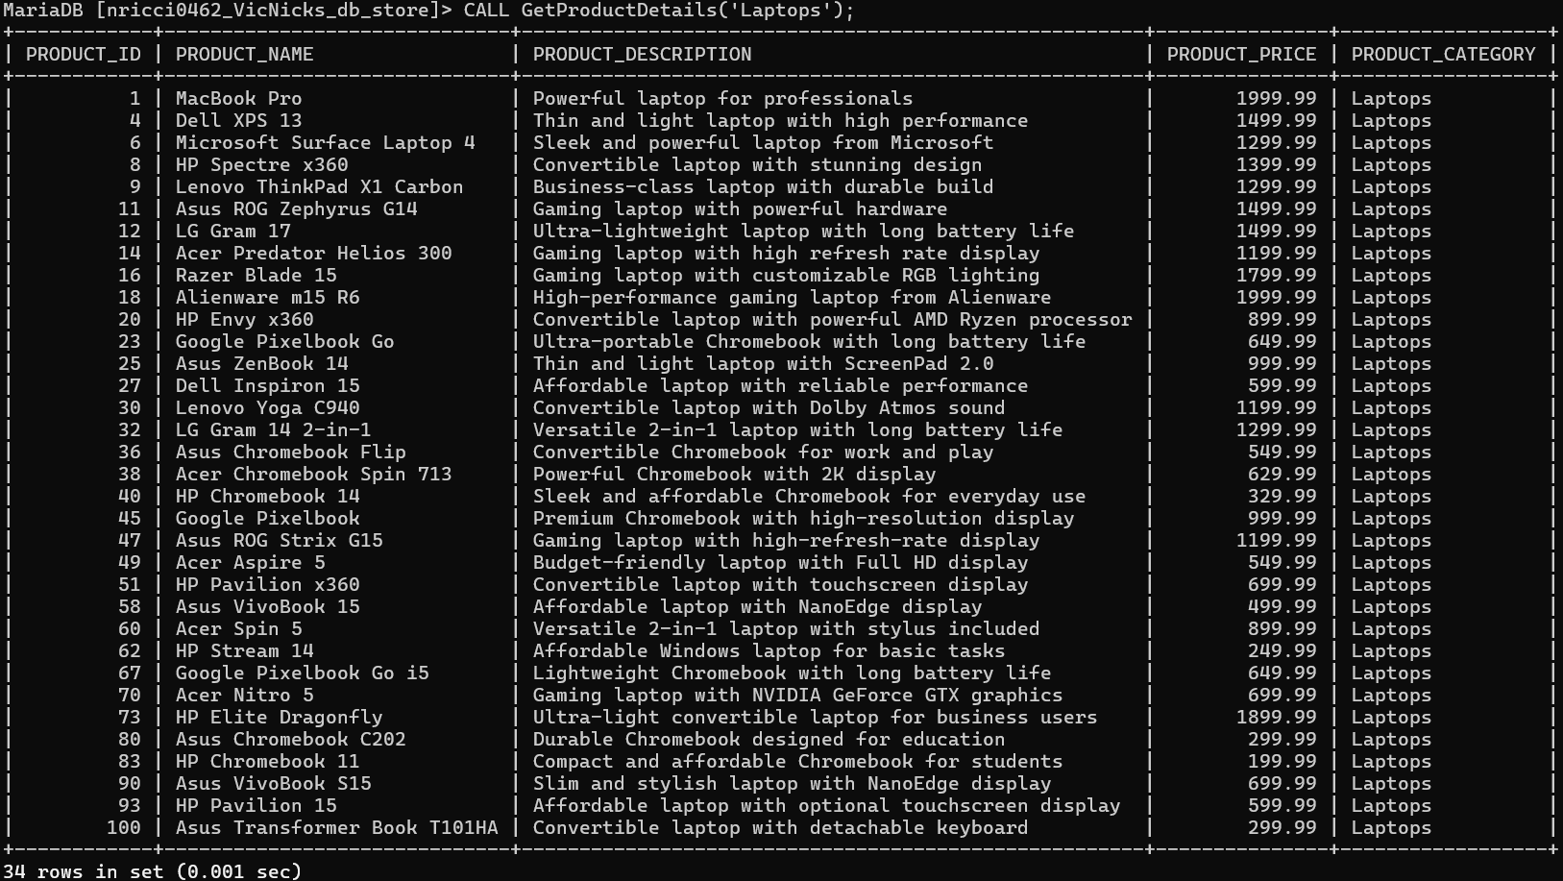

SQL Code used to insert a new product into the product table
MariaDB> INSERT INTO PRODUCT (PRODUCT_NAME, PRODUCT_DESCRIPTION, PRODUCT_CATEGORY, PRODUCT_PRICE) VALUES (‘New Laptop’, ‘Powerful laptop with high-resolution display’, ‘Laptops’, 1599.99);
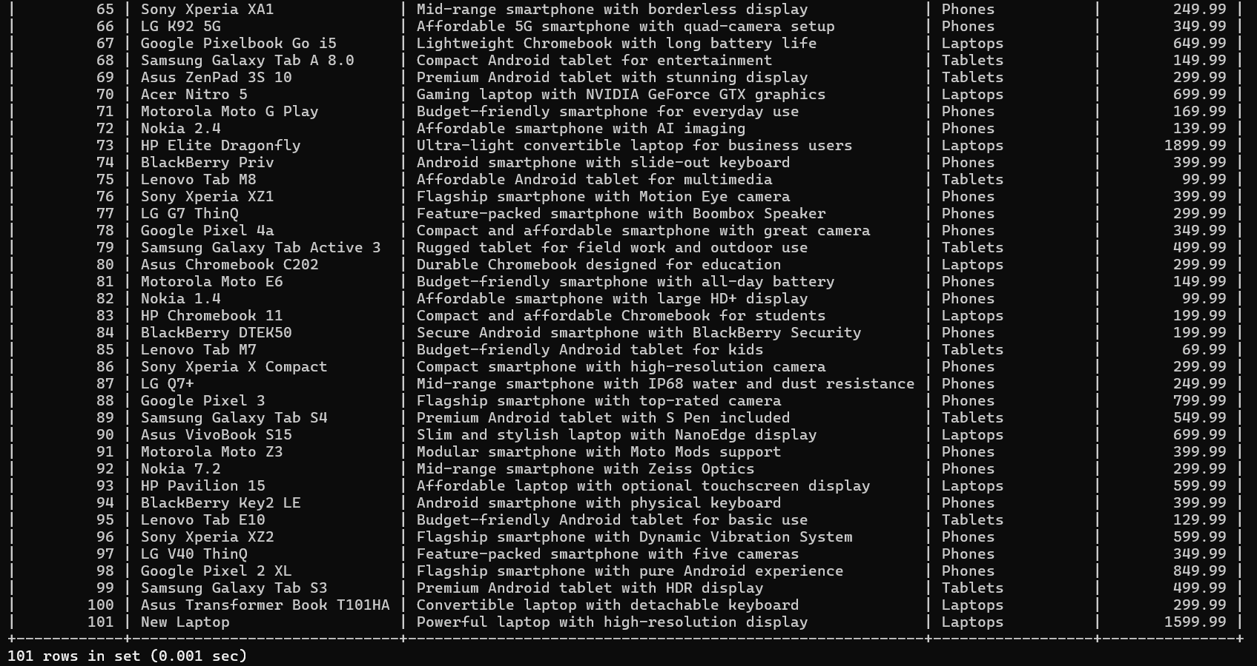

SQL Code used to generate a new invoice
MariaDB> INSERT INTO INVOICE (CUS_ID, INV_DATE, INV_STATUS, INV_PAYTYPE, INV_TOTAL_AMOUNT) VALUES (11, ‘2024-04-01', ‘Pending’, ‘Credit Card’, 1299.99);
MariaDB> SELECT * FROM INVOICE;
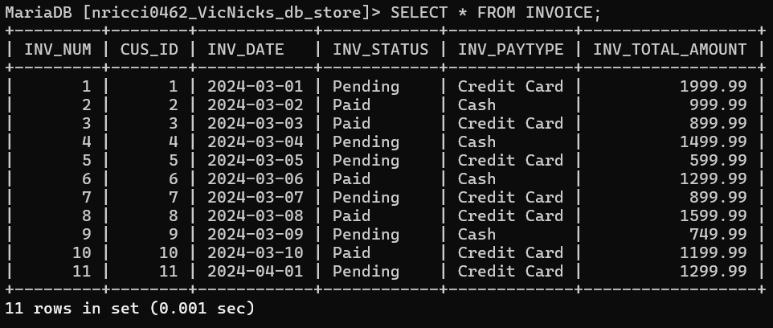

Output of a virtual table
MariaDB> CREATE VIEW EMPINQ1 AS SELECT E.EMP_NUM, E.EMP_FNAME, E.EMP_LNAME, D.DEPARTMENT_NAME FROM EMPLOYEE E JOIN DEPARTMENT D ON E.DEPARTMENT_ID = D.DEPARTMENT_ID;
MariaDB> SELECT * FROM EMPINQ1;
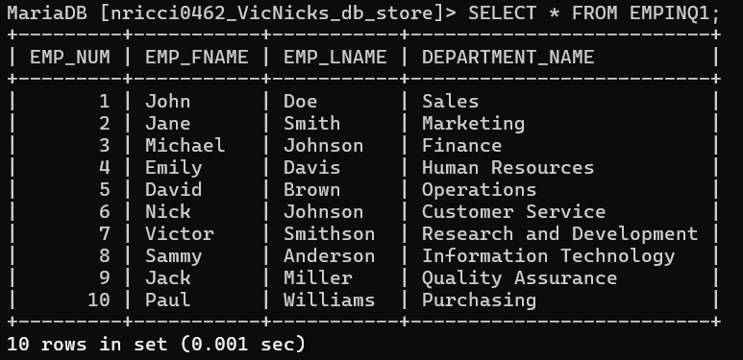

Data Dictionary of Tables
MariaDB> SELECT table_name, column_name, column_type, is_nullable, column_comment FROM information_schema.COLUMNS WHERE table _schema = ‘nricci0462_VicNicks_db_store’ ORDER BY table_name, ordinal_position ASC;
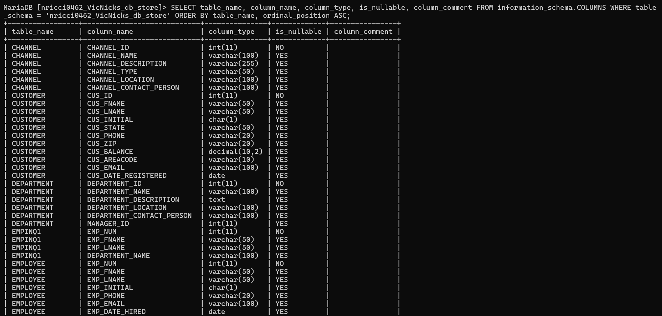
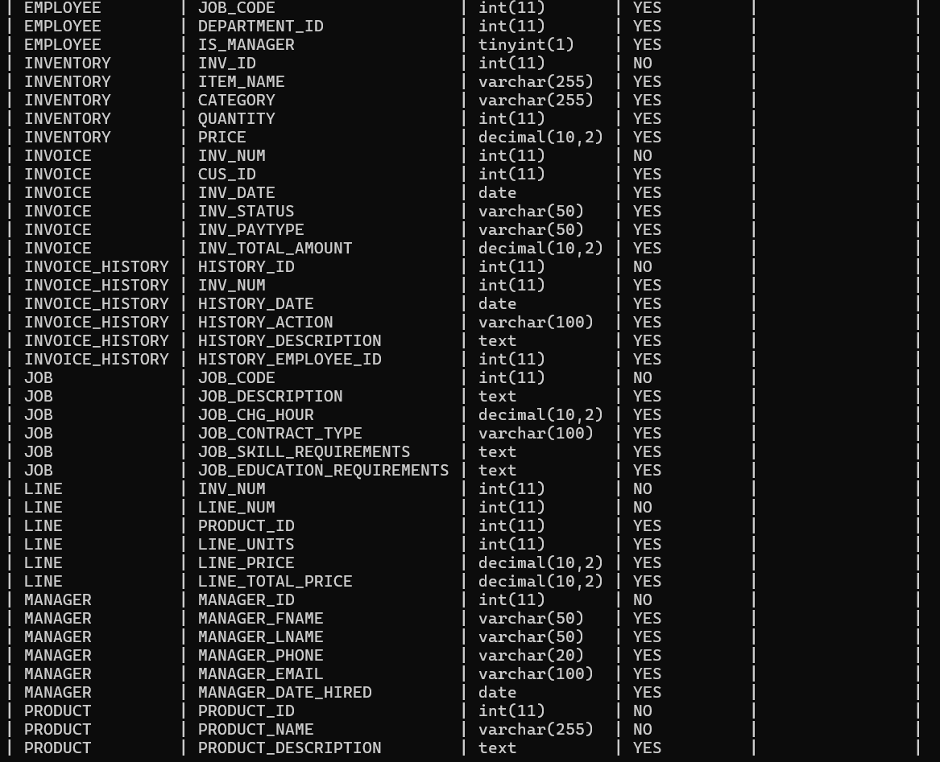
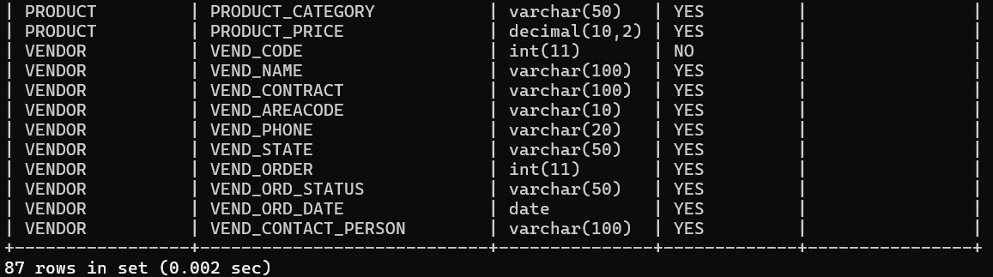

Summary of Database Solution / Conclusion to Business Proposal

VicNicks' strategic decision to embrace a comprehensive database solution signifies a significant milestone in its quest for operational excellence and sustainable growth. By conscientiously acknowledging the constraints imposed by outdated data management practices and opting for modernization, VicNicks showcases its proactive approach to navigating the ever-evolving tech landscape. Through the transition from conventional spreadsheets to a sophisticated database architecture, VicNicks sets out to streamline its operations, bolster data accessibility, and furnish decision-makers with actionable insights to drive informed strategies and decisions.

At the core of this transformative initiative lies a meticulously crafted database schema meticulously designed to encapsulate the pivotal aspects of VicNicks' multifaceted operations. Spanning from robust customer relationship management to the intricacies of sales and inventory management, each facet is intricately woven into the schema, meticulously crafted to align with established business rules and constraints. This conscientious approach ensures that the database infrastructure serves as a reliable foundation for seamless data integration and fosters deeper operational insights, empowering VicNicks to stay agile and responsive to market dynamics.

The envisioned database solution not only seeks to address immediate operational challenges but also positions VicNicks for sustained success and ongoing innovation. Leveraging cutting-edge technologies and adhering to industry best practices, VicNicks is primed to elevate operational efficiency, foster agility, and deliver unparalleled value to its discerning clientele and stakeholders. With a robust foundation now in place, VicNicks embarks on its transformative journey with confidence, poised to emerge as a trailblazer in the competitive tech landscape, equipped to seize emerging opportunities and overcome challenges with resilience and foresight.

Percentage of Effort by Each Team Member and Responsibilities

Team Member | Percentage of Effort | Responsibilities
Nicholas M. Ricci | 50% | SQL commands/output, Cover Page, Executive Summary, Problems Constraints and Objectives, Scope and Boundaries, Summary of Database Solution/Conclusion to Business Proposal
Victor K. Dimitrov | 50% | Data Dictionary, Entity Relationship Diagram, Cover Page, Executive Summary, Problems Constraints and Objectives, Scope and Boundaries, Summary of Database Solution/Conclusion to Business Proposal

